

Draw it or lose it

CS 230 Project Software Design
Version 3.0

Table of Contents

CS 230 Project Software Design Template 1
Table of Contents 2
Document Revision History 2
Executive Summary 3
Requirements 3
Design Constraints 3
System Architecture View 3
Domain Model 3
Evaluation 4
Recommendations 7

Document Revision History

Version | Date | Author | Comments
1.0 | 11/16/2025 | William Joffe | This document has been edited to align with a formal software design document for our client, The Gaming Room. We’ve added new sections to the document going over Domain Model analysis, Platform evaluation, and architecture recommendations for planned infrastructure.
Version | Date | Author | Comments
2.0 | 11/29/2025 | William Joffe | This document has been edited to further align with the clients’ specifications and dive deeper into some areas of client concern, specifically Platform Evaluation and Technical recommendations.
Version | Date | Author | Comments
3.0 | 12/14/2025 | William Joffe | This document has been edited to give concrete recommendations to the client on what their game should use for their System Architecture, security, and networking.

Executive Summary

The Gaming Room is hiring us to develop a solution for their game Draw it or Lose it. We are developing this solution in Java using OOP. GameService, which uses a singleton pattern, will serve as the one source of truth and manage all games, teams, and players. This provides a good starting point, and we can reconfigure if the player count ever grows.

Requirements

- The system must provide a stable backend.
- The backend must be capable of managing multiple games, teams, and users concurrently.
- The solution must be a self-contained, single-instance application to ensure development simplicity.
- The system must be accessible to players on all major desktop and mobile platforms.

Design Constraints

- The system's core logic must be controlled by a central GameService class implemented using the singleton design pattern.
- All development must follow Object-Oriented principles and be based on the provided UML class diagram.
- The application must be thread-safe to handle simultaneous actions from multiple users without causing data corruption.
- All active game states, including players and teams, will be managed in-memory for the application's runtime.

System Architecture View

Please note: There is nothing required here for these projects, but this section serves as a reminder that describing the system and subsystem architecture present in the application, including physical components or tiers, may be required for other projects. A logical topology of the communication and storage aspects is also necessary to understand the overall architecture and should be provided.

Domain Model

This UML class diagram shows the structure for the Draw it or lose it web app. The main entry point is the Program Driver which uses a singleton tester to verify the core services work. The GameService class is using the singleton pattern which assures that only one instance every exists. This allows one source of truth and a singular access point for all game logic/data.

The GameService class can manage 0-to-many Game instances, the game class can have 0-to-many teams, and the Team class can have 0-to-many players. The Game, Team, and Player classes all inherit from the Entity class, so they all share common attributes.

The two main OOP used here are Inheritance and Encapsulation. We use Inheritance to reduce code duplication and promote a structure for our core systems. This is essential for creating a consistent foundation to build new classes from. Finally, we use Encapsulation to keep certain class attributes private so we can control what classes can access them and if so, we develop public getters and setters. This allows us to know which classes can access important data and prevent unauthorized changes.

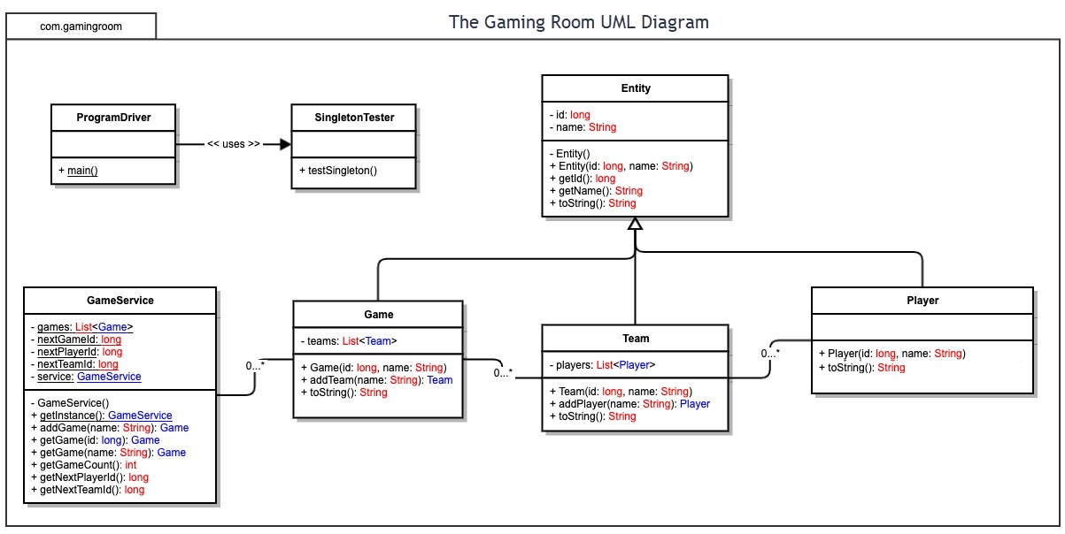

Evaluation

Development Requirements | Mac | Linux | Windows | Mobile Devices
Server Side | Mac is built on Unix architecture and can be used to run servers, but the company stopped selling servers in 2022. This alone means we should consider other options. | Linux is by far the most popular choice for the industry to host a backend for a web application. By choosing Linux we can expect scalability using Docker/Kubernetes, stability, performance and most importantly top-notch security. There are no licensing costs. | Window Server has a very large platform purpose built for hosting applications. I would only choose windows if your company’s assets were already integrated into the Microsoft ecosystem. You can expect to have a higher cost for windows servers due to licensing. | Both Android and Apple are built from the ground up to be clients, not servers.
Client Side | Macs are the second most popular option when consumers are browsing the web. Since this is a web application, we need to make sure Safari is supported. We will need to integrate webkit for safari support. | Linux is the least popular choice for consumers when browsing the web. They do not have a native web browser and most distros by default install Firefox or another privacy focused browser. Time will need to be spent on supporting non chromium-based browsers. | Windows is the most popular option for consumers browsing the web. We will need to support all major browsers such as Chrome, Firefox, Opera, Edge, etc.  We will need to develop resolution break points due to windows default scaling being 125% on most laptops sold which will cost developer time. | We will implement a mobile first approach on the front-end. This requires using mobile breakpoints that dictate which “version” of the website the end user will see. We must have a responsive layout that changes appropriately due to device orientation or size. We need to respect the back button and gestures within the frontend UX/UI.
Development Tools | Since we are going for cross compatibility, IntelliJ, Eclipse, and VS Studio are the most relevant IDE for developing and publishing web applications like ours on a Mac. IntelliJ requires a licensing fee per developer which will raise costs, but this is the case for every single OS. Swift, Python, Java, and C, C++ are some of the most popular languages.  Hardware wise, it will be more expensive to supply your employees with Macs over any other option. | IntelliJ, Eclipse, and VS studio are also supported on Linux and would give us the same power to publish our application using the power of JVM. The main benefit to Linux is that our frontend and backend development will take place within the same architecture we would be using to host the system. This speeds up development and troubleshooting. | Windows is the industry standard for enterprise workstations, meaning hardware and OS licensing costs are likely already covered. While it supports all required IDEs, like the last two operating systems we discussed, its file system differs from our target Linux server. Developers on Windows must use Docker to containerize the application. This adds another cost to development. | Android Studio, Xcode, and VS Studio are the most relevant IDE for developing and publishing web based applications on both iOS and Android. Android Studio uses Kotlin natively and Xcode uses Swift natively. VS Code allows you to use something like React and Electron to build applications that will run on both operating systems.  Developing programs on android or iOS is extremely niche and not possible for this project.

Recommendations

- Operating Platform: Linux is the clear choice for Draw it or Lose it. The platform is designed to work with all major clients across every ecosystem. It doesn’t require any licenses, and it is the platform developers are most familiar with which will help streamline costs.

- Operating Systems Architectures: Linux is built for speed, security, and efficient process scheduling and concurrency, which makes it ideal for running our game server. If our game server crashes, we can also schedule automated reboots allowing for minimal downtime. Linux provides kernel-level control, meaning we can manage exactly how our game server uses system resources such as CPU threads, allocated RAM, networking bandwidth per client, and storage. This level of control lets us tune the system specifically for game hosting. We can also utilize “headless" architecture to ensure 100% of system resources are devoted to game logic. Because we control everything at the kernel and system level, we can run only the exact dependencies our game server requires with no extra bloat. This results in maximum uptime, faster performance, and predictable scheduled backups of all game data we can implement using a scheduler.

- Storage Management: We require persistent server level memory for this project. We want to be able to delete user information if their accounts are old or deactivated and easily backup data on a schedule. Due to these requirements, we need a relational database like PostgreSQL. Although this database requires a separate server to run, lighter options such as SQLite could result in database locking due to too many DB writes at the same time. Even with WAL mode enabled, the saving might feel slow once your game has a lot of concurrent users. Postgres will allow you to scale and manage all the related data from your game and ensure your users expectations are met.

- Memory Management: The Linux operating system will manage the server's RAM using virtual memory and paging, allocating resources to our application. Within the application, the Java Virtual Machine manages its own memory heap. JVM’s automatic garbage collector will handle memory allocation and deallocation for the entire system, which simplifies and lowers the costs of development. This can help handle memory leaks when the system detects unreachable objects, which is the main reason why JVM’s garbage collector is so famous.

- Distributed Systems and Networks: Our application will use the proven client-server model where all devices communicate over the network. We will use HTTPS for secure requests and Web Sockets to send real-time game information as fast as possible. To keep ping time low for our players, the server should be generally located near them. We should aim to target a server location in the Central United States to accommodate most users. While we will launch with a central server, this client-server architecture allows us to introduce a Load Balancer in the future. This would distribute traffic across multiple servers if the player base expanded, preventing any single server from becoming a bottleneck.

- Security: The security of User’s Information is of the utmost importance. We will encrypt all network traffic with TLS. All sensitive information in the database will be encrypted using the latest technology. Finally, all passwords will be salted and hashed. We will offer users two factor authentication to protect their accounts and ensure that only account owners are accessing their accounts. To protect our database from injection attacks, the application will use prepared statements and sanitize all user inputs coming from the client. On the server side, we will configure our firewall to block all unwanted traffic and only open the ports necessary for the functionality of the product. File permission will block any unwanted visitor from breaching secure locations on our server. The server will be updated as needed to install any patches for new vulnerabilities and we will implement those patches during a time that least affects our users.

